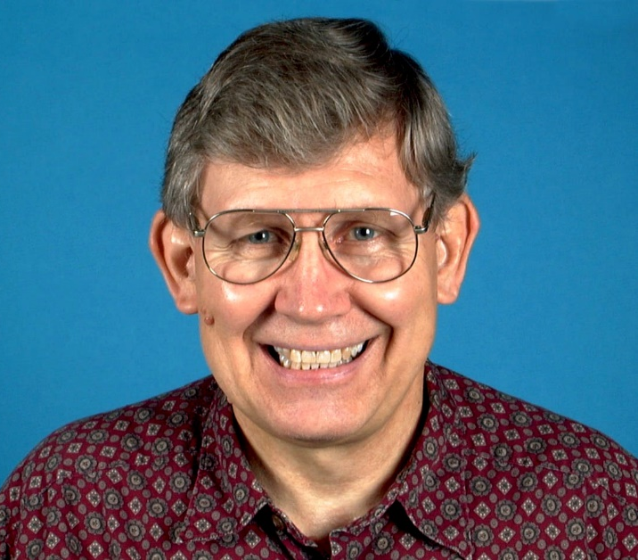
GARY R. BUCKINGHAM Dec. 7, 1942 – Jan. 16, 2017

Gary R. Buckingham, Retired USDA-ARS Research Entomologist and a world-renowned expert in biological control of weeds passed away on January 16, 2017 at Richmond, CA. Gary was born to Richard and Ione Buckingham in Rapid City, South Dakota. Gary's family moved to La Porte, Indiana where he completed high school and continued his education, receiving Bachelor of Science in Agriculture (BSA) with distinction in Entomology from Purdue University in 1964. Gary then moved to the San Francisco Bay Area where he earned his Ph.D. in Entomology from the University of California Division of Biological Control, Berkeley, in 1975. He carried out his research at the university’s Gill Tract-Albany Lab. His Ph.D. dissertation was titled “The parasites of walnut husk flies (Diptera: Tephritidae: Ragholetis) including comparative studies on the biology of Biosteres juglandis Mues. (Hymenoptera: Braconidae) and on the male tergal glands of Braconidae (Hymenoptera)”. At some point during his graduate studies, Gary participated in a collecting expedition to Barro Colorado, Gatún Lake, Panama, a tropical island known for its faunal diversity that is administered by the Smithsonian Tropical Research Institute with ongoing studies on tropical ecosystems.
While at Berkeley Gary met and married May (Narasaki) Buckingham, his beloved wife of 46 years.
In 1970, Gary was sent to the USDA-ARS lab in Rome, Italy by the UC Division of Biological Control to study biological control of field bindweed, Convolvulus arvensis, and yellow starthistle, Centaurea solstitialis. In 1972, he was hired by the ARS as Research Entomologist and Leader at the Rome lab. His studies included insects attacking thistles, Dalmatian toadflax (Linaria dalmatica), and opium poppy, Papaver somniferum.
In 1977, Gary was transferred to Gainesville, Florida where he and May spent the next 25 years. Gary was a member of the ARS, Invasive Plants Research Laboratory (formerly Aquatic Plant Control Research Unit), Ft. Lauderdale, Florida but worked at the quarantine facility of the Florida Biological Control Laboratory at the Division of Plant Industry (DPI), Gainesville. He was also a Courtesy Assistant Professor in the University of Florida Department of Entomology and Nematology in Gainesville.
Gary’s research included studies of the biology and host range of foreign insects with potential for biological control of the Australian weeds, melaleuca, Melaleuca quinquenervia, and old-world climbing fern, Lygodium microphyllum, both of which threaten the Everglades and the South Florida ecosystems. He had extensive foreign experience having conducted explorations and field collections in 20 countries for insects to control weeds as well as insect pests and having traveled to 19 additional countries for meetings and visits. Gary also made highly significant research contributions to the ARS’ efforts to control alligatorweed, Alternanthera philoxeroides, Eurasian watermilfoil, Myriophyllum spicatum, hydrilla, Hydrilla verticillata, and waterhyacinth, Eichhornia crassipes, with insects. Upon retiring from the ARS in 2004, Gary and May moved to and settled in Sacramento, California.
Through his career, Gary published numerous research papers and other publications highlighting his studies and gave numerous talks at national and international scientific meetings. His research took him abroad to several countries and the travel fit in well with Gary's interests in collecting not only insects but also antiques and experiencing foreign cultures and food, especially desserts. Gary was an avid photographer and usually had his camera ready to capture interesting shots of 'bugs', nature, antiques, and people. He was also a good, keen tennis player.
News of Gary’s death brought several loving tributes from his friends and associates, such as, “If TAG [USDA-APHIS’ Technical Advisory Group on Biological Control of Weeds with exotic insects and pathogens] received a petition to release a biocontrol agent from Gary Buckingham, you could guarantee 100% it was safe to release” (Al Cofrancesco). “His science was impeccable, both novel and unbelievably thorough. Above all, Gary was a true Gentleman” (Matthew Purcell). “Gary Buckingham played an important role in the early stages of my work with decapitating flies while I was still over at DPI” (Sanford Porter). “I did not know him so well but we always had very positive interactions” (Richard Mankin). “When Reece Sailer died in 1986, I was asked to take over teaching the University of Florida's graduate-level Biological Control course. It was to … have about 30 lectures and half that number of "laboratory classes". I wanted perhaps two of the lectures to focus on biological control of weeds, but how to achieve that when I had not worked on this subject? If I were to do so, my lecture would be sterile. So, I talked to Gary and… he was willing to give those two lectures. It was a happy day when he told me that, and I was still happier when I heard his first inspired lecture and learned from it, so that eventually I was able to give his lectures. When Gary and May left for California, biological control enthusiasts in Gainesville lost contact with a good friend. But by that time, I had learned enough of Gary's subjects that I then gave the lectures he had taught”. (J. Howard Frank). “He would often set up a light trap at the back of his house to see what was fling at night. I remember the light reflecting off the eyes of a nearby alligator. Not too many entomologists run night traps at home, only those who really love insects” (Lloyd Andres).
Gary is survived by his wife May, stepson Keith (May) and stepdaughter Ellen Narasaki, and grandchildren Kimiye and Cody Miles and Keiko Narasaki. He was predeceased by his parents and sister Kay. Gary's pleasant and engaging personality and generous spirit will be missed by family and friends.

May Buckingham
5867 McBryde Ave
Richmond, CA 94805
510-232-3277

Great granddaughter, Maiya Emiko Miles, born 3/30/2017

